**2024-2025 Competition Season**

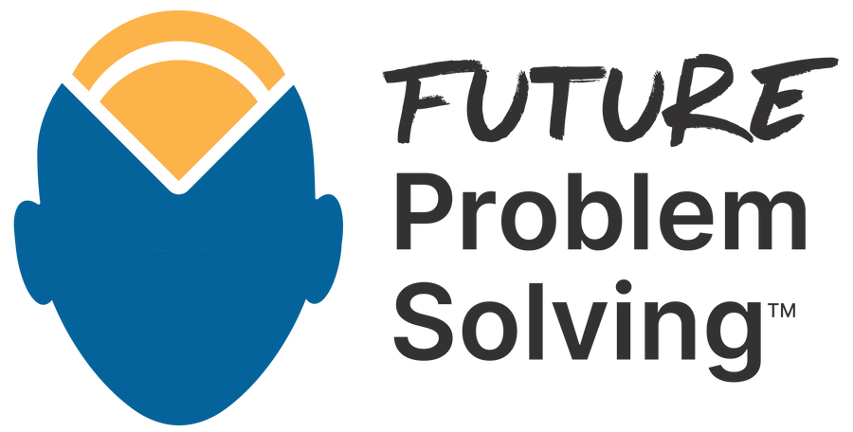

**Affiliate Finals Problem**

Supports all these programs

Nanotechnology

**Science & Technology**

How might the use of nanotechnology in medicine, healthcare, and other industries affect humanity in the future?

# Context

Nanotechnology is widely used in food industries, medicine, energy, automobiles, the environment, electronics, textiles, and cosmetics. Nanotechnology has direct benefits for medicine and the environment, but it may have unintended effects, like all technologies. Nanoparticles of typically unharmful materials, for example, can be toxic if inhaled. Not easily observed, nanotechnology poses risks to security and privacy.

# Background

Nanotechnology deals with dimensions and tolerances of less than 100 nanometers. A single strand of human hair, for scale, is typically 100,000 nanometers thick! At this scale, individual atoms of larger materials can be manipulated. Placing atoms as though they were bricks, nanotechnology has the potential to give control over the structure of matter, allowing us to build powerful, yet microscopic substances.

# Challenge

What advances for society could new nanotechnology products enable?

How might nanotechnology benefit all sectors of society?

As the technology becomes more commonplace, how can we prepare for the unexpected risks and dangers associated with its use?

# Central Themes

1. Nanotechnology on the market
2. Nanomedicine
3. Nanotechnology and the environment
4. Into the unknown

*Visit our topic center to learn more about our Nanotechnology topic, view suggested readings and access additional resources.*

**Contact Affiliate Future Problem Solving**

**Email:**

[vafutureproblemsolving@gmail.com](mailto:vafutureproblemsolving@gmail.com)

**Call:** 804-310-4545

**Visit:** vafps.org